**Farm Program – Footer Recommendation**

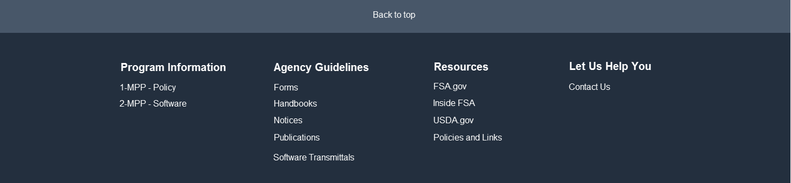

|  |  |
| --- | --- |
| **Footer Link** | **Navigates/Prompts to…** |
| Back to top | Top of the web page. |
| 1-MPP – Policy | Open or save the specific handbook in Adobe. |
| 2-MPP – Software |
| Forms | <http://fsaintranet.sc.egov.usda.gov/dam/ffasforms/forms.html> |
| Handbooks | <http://fsaintranet.sc.egov.usda.gov/dam/handbooks/handbooks.asp> |
| Notices | <https://www.fsa.usda.gov/FSA/notices?area=home&subject=lare> |
| Publications | <http://fsaintranet.sc.egov.usda.gov/fsa/FSAIntranet_newsroom.html> |
| Software Transmittals | <https://inside.fsa.usda.gov/operations/ocio/software-release-transmittals/index> |
| FSA.gov | <https://www.fsa.usda.gov/> |
| Inside FSA | <https://inside.fsa.usda.gov/> |
| USDA.gov | <https://www.usda.gov/> |
| Policies and Links | <https://www.fsa.usda.gov/help/policies-and-links> |
| Contact Us | Opens a page similar to the following. However, more discussion is needed to ensure the content of this page meets all program area needs.  <https://inside.fsa.usda.gov/help/contact-information/index> |